**Trustee Recruitment Pack**

**June 2021**

# Thank you for your interest in joining our Board of Trustees

We are a charity that has delivered award winning care, community, special education and family support services in the North West of England for over 150 years. Our development and direction has been underpinned by huge commitment given by over 900 staff and volunteers including Trustees, Governors, and Members past and present.

We would like to expand our Board of Trustees and it is an exciting time to join us. We are currently shaping our new 5 year plan to deliver even greater impact to the people and families we support, which you will have a key role in shaping and influencing. We have also embarked on a journey to improve equality, diversity and inclusion across our governance and leadership structure, our workforce and our services.

Our operating environment is challenging, with our services facing financial pressures and ongoing government policy issues which do not always reflect the interests of the 2000 people we support each year.  We therefore want to increase our influence regionally and nationally to improve the environment in which the people we support live and learn.

We believe we will deliver long lasting social impact when our Board and leadership teams reflects the community of people and families we are here to serve. Improving Board diversity is crucial for us in terms of our values as an organisation. It means we are more effective, make better decisions and is key to effective delivery of our mission.

We are actively encouraging applications from people who are Black or a minoritized ethnicity, disabled, LGBTQ+ and/or have varying levels of educational attainment. We particularly welcome applications from younger people aged 18 to 30 and we are also interested in hearing from candidates with a background or advanced knowledge in:

* Equality, diversity and inclusion
* Fundraising and/or social value
* Special education
* Safeguarding
* Lived experienceof any specialist area in which we work.

The people we support are at the heart of all we do. They help us to drive and lead positive social change. If you have experience of receiving care, special education, community or clinical support or you have a close family member who has used a service like this we’d also warmly welcome your application.

You need to have compassion, empathy and sensitivity to the experiences of the people we support, as well as willingness and openness to understand the complexity of their circumstances. **You can read more about our current vacancies on pages 9 -11 of this pack.**

Trustees lead the development of our charity. Their professional and technical skills, alongside their values and behaviours that mirror those of the Trust are of paramount importance. You have a significant opportunity to help shape the strategic direction of one of the North West’s oldest and largest care charities. Working in collaboration with the people we support to provide evidence to help to influence policymakers and make lasting societal change.

This is a truly unique charity, with people who care deeply about what they do. If you believe you have the experience and qualities we’re looking for, then we would love to hear from you.



Giles Gaddum, Acting Chair of Trustees

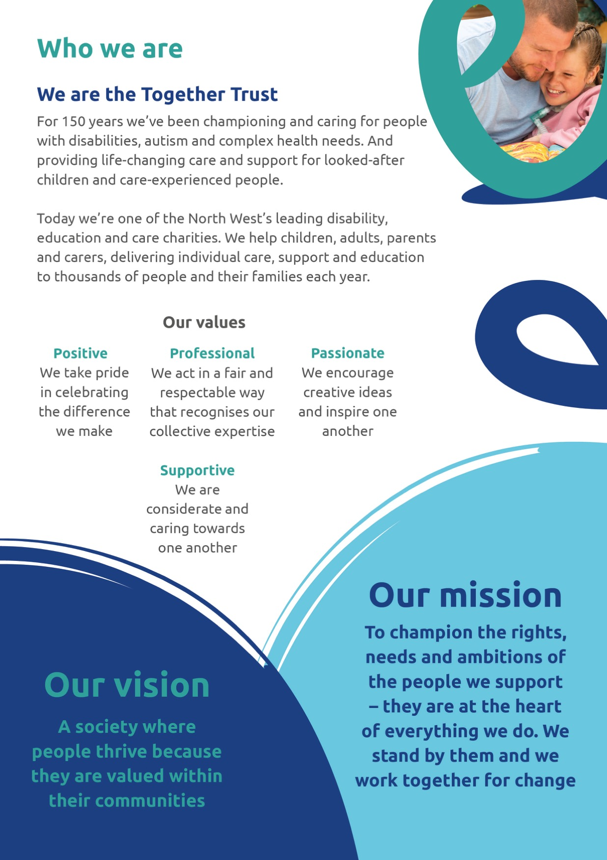

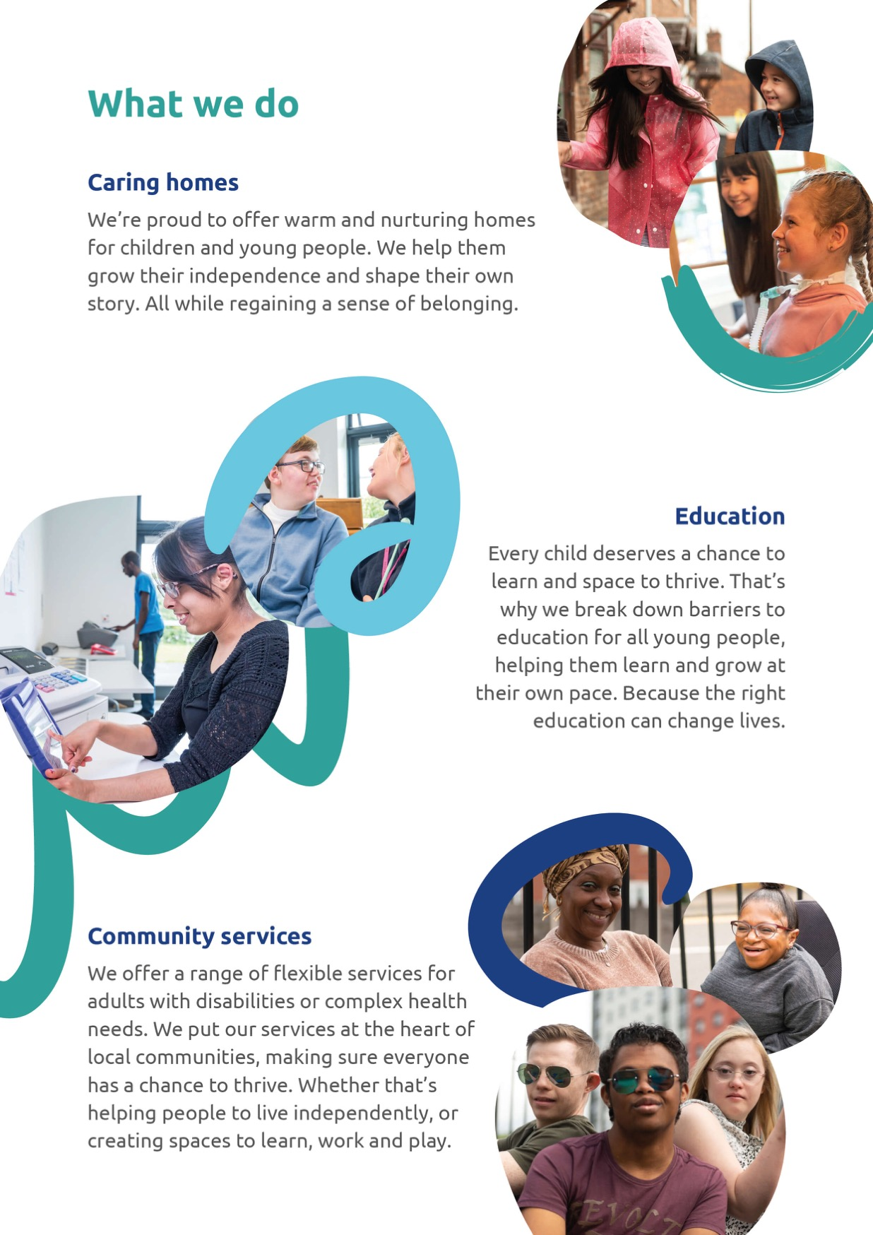

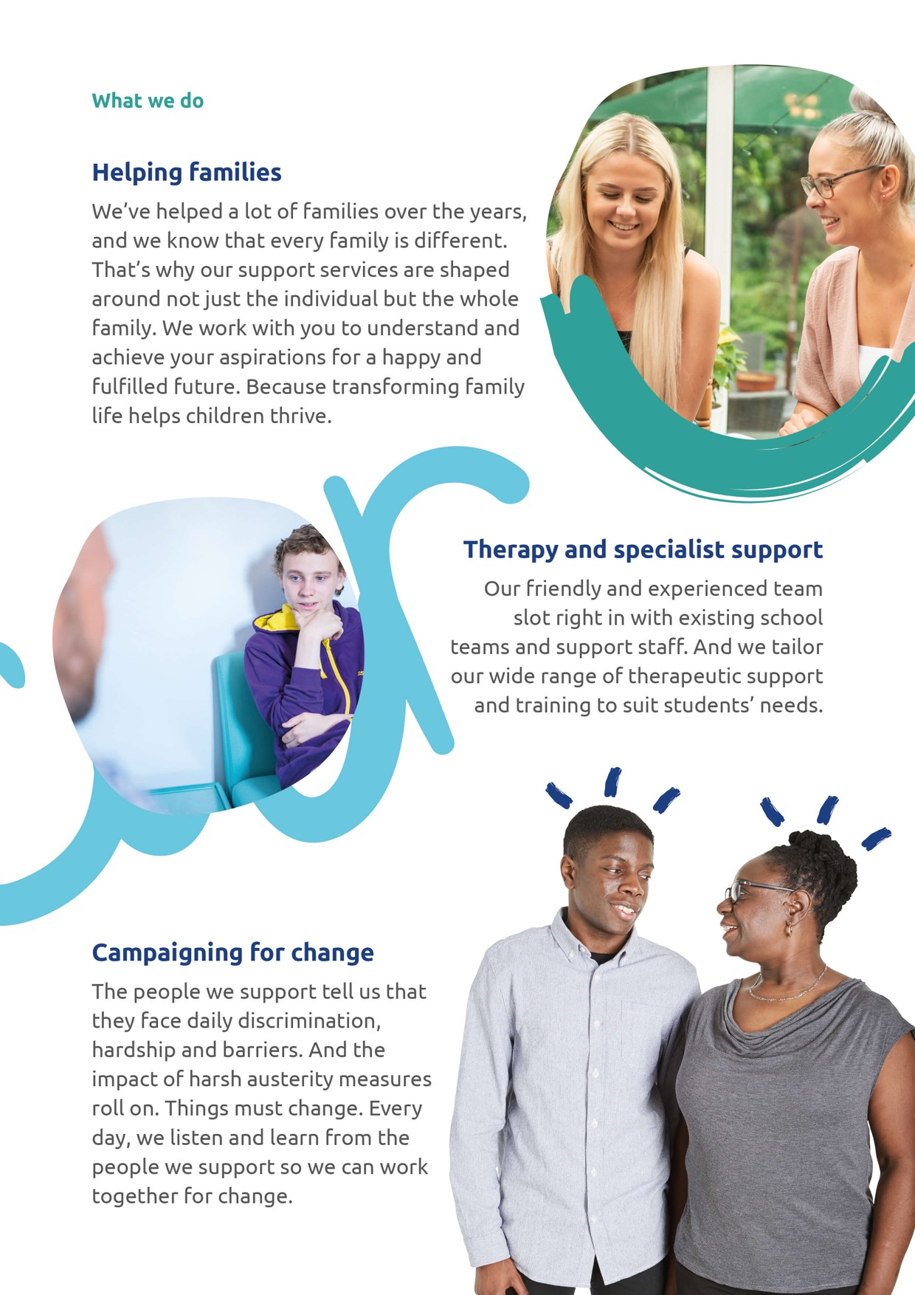



# Our Board of Trustees

Our Board is responsible for agreeing the strategic direction of the charity, setting the budgetary framework and deciding upon major undertakings. Responsibility for the day-to-day operation of the Trust is delegated to Mark Lee, our Chief Executive, who reports to the Trustees on a regular basis. This ensures that our Trustees have all the information they need to monitor progress and agree any strategic or budgetary adjustments which may become necessary.

We elect our Honorary Officers every year. These Officers are also Trustees and are the Chair and Vice Chair of the Board, and Chair and Vice Chair of the Finance & Audit Subgroup. All Trustees can put themselves forward for these roles and our next elections will take place in autumn 2021.

As a Board we must always

* act in the best interests of the Together Trust, exercising the same standard of duty of care that a prudent person would apply if looking after the affairs of someone for whom they have responsibility
* act collectively as a group and not as individuals
* ensure that all of our decisions and actions are consistent with the Together Trust’s values and how the charity is seen by the people and organisations who are involved in our work and by the wider public.
* have regard to the proper use of our power and act in line with our Charity Articles and our own aims and values
* that the Trust follows the law. We also consider non-binding rules, codes and standards, and follow, for example regulatory guidance, the [Charity Ethical Principles](https://www.ncvo.org.uk/policy-and-research/ethics/ethical-principles) and other good practice initiatives that promote confidence in charities and create a supportive environment.

You are not expected to have a detailed knowledge of the legislation that governs our work as our staff will support you. However, you should be aware that legislation exists and where necessary you should be satisfied that the Together Trust has Policies and Procedures and reporting mechanisms in place in order to ensure compliance.

# Equality, Diversity and Inclusion

# The events of 2020 have force us to reflect on our own practices and understandings in relation to equality, diversity and inclusion. Charity So White has highlighted institutional racism within the charity sector, and ACEVO’s Home Truth’s report spotlighted the scale of the challenge. We have been reflecting on what steps we need to take to see meaningful change for the people we support.

We all agree that this change needs to be a fundamental shift in the way we do things at the Together Trust, and it must outlive us. ✊🏽🖤🏳️‍🌈

We still have a profound sense that we are at the beginning of this journey and whilst there will not be an end to this work, we are at the start of a two-to-three-year programme of activity focused on three key areas: our governance, our workforce and improved EDI for the people we support. [Read our full statement here >](https://www.togethertrust.org.uk/news/our-commitment-addressing-inequality)

Our Board have formed an Equality, Diversity and Inclusion (EDI) Steering Group to provide support, advice and assurance for Trustees and Governors to ensure that we have a strategic approach to building a greater equitable and diverse culture within our Board, Governing Bodies and Subgroups. This steering group leads the Board on its journey to improve EDI. You can learn more about our EDI governance [here](https://www.youtube.com/watch?v=9D4hOITlLpo) in a short film made by Helen, a Trustee, Governor and an EDI Steering Group member.

# Our Stronger Together Plan

During 2014, our Board agreed a six-year strategic plan known as ‘Stronger Together’. In early 2018, the Charity updated its strategic vision and goals. The revised plan lays out the Trust’s vision for how it will become stronger together between 2018 - 2022.

To achieve our plan, we identified four key strategic goals:

* Deliver high quality, person centred, effective and cost-efficient services to vulnerable individuals and families. Our integrated services adapt and evolve to meet the life-long changing needs of individuals. We work in partnership to achieve the very best outcomes possible for the individuals we support.
* Be a trusted partner to the individuals we support. Our personalised services enable people to make positive progress.  We support individuals who use our services to help them influence future policy and provision.
* Grow, develop and expand our reach as a provider of choice to maximise our impact and ensure that we can sustain our future as an organisation. We develop integrated pathway services and will grow organically and sustainably to meet changing needs of the individuals we support and funders’ requirements.
* We aim to attract and retain a skilled and motivated workforce who are treated equitably and fairly and have clear learning and development opportunities. Our workforce is dedicated to helping those in need and work collaboratively and live our values. We listen to our workforce and work with our Staff Council to ensure effective engagement.

It is an exciting time to be a member of our Board of Trustees. In autumn 2021 our Board will consider proposals over the next 5 years to deliver even greater impact to the young people and families we support. Our operating environment is challenging, with our services facing financial pressures and ongoing government policy issues which do not always reflect the interests of the 2000 people we support each year. We therefore want to increase our influence regionally and nationally to improve the environment in which the people we support live and learn.

The Board monitors progress against the strategic aims in the Stronger Together plan by measuring Key Performance Indicators relating to specific areas of the Charity’s operations and support services. Each Board subgroup receives KPIs relating to their specialist area either monthly or quarterly.

The Board also appoints the Chief Executive and assists the Chief Executive to appoint Directors.

# Trust Subgroups & Governing Bodies

We operate two special schools in Stockport; [Ashcroft](https://www.togethertrust.org.uk/ashcroft) and [Inscape House School](https://www.togethertrust.org.uk/inscape-house-school) and [Bridge**,**](https://www.togethertrust.org.uk/bridge-college) which is a further education special college in the centre of Manchester. Each have their own Governing Body.

The Trust also maintains a number of Trustee-led special purpose subgroups that undertake specific tasks which contribute to the charity’s governance and operation such as Safeguarding Scrutiny, Governance, Human Resources & Organisational Development, Finance & Audit and Supporting People. All Trustees are encouraged to join one or more subgroups that convey their area of interest.

The Board appoint two Trustees who are the Chair and the Vice-chair of each of these groups or Governing bodies who all report into the Board in line with the charity’s planning and performance management cycle.

# What’s involved in being a Trustee

**Time commitment**

We estimate the role could take up to 4 hours a week if you attend Board meetings and are involved in one of our Subgroups or Governing Bodies. Many of our existing Trustees work full time and can provide advice and guidance about managing balancing your time commitments.

Our Board meet six times a year on the first Friday of the month and at the moment these are held during normal office hours. Most meetings last approximately from 9.30am – 1pm and are held virtually or at the charity’s central office in Cheadle. We aim to distribute papers electronically one week in advance of meetings.

**Location**

At the moment, most of our work as a Board is virtual but we hope to return to face to face meetings in the future. Ideally, when it’s safe to do so, we’d like you to be able to visit our services which are mostly in or around Greater Manchester and the surrounding areas to get to know our staff and the people we support as part of our Trustee Service Visit programme.

**Term of office**

Trustees are appointed for a minimum of 3 years and can continue for a further two periods of 3 years (maximum term 9 years).

**The role is voluntary**

Trustees are volunteers and their role is unpaid; however, we reimburse reasonable out-of-pocket expenses. This does not form any type of employment contract and should not be interpreted as such.

**The formal role**

Trustees have, and must accept, ultimate responsibility for directing the affairs of the Together Trust, ensuring that it is well-run and delivering the charitable outcomes for the benefit of the public for which it was formed. The Board ensures that all of its decisions and actions are consistent with the charity’s values.

Trustees must ensure that the Together Trust complies with:

* charity law, and the requirements of the Charity Commission as regulator
* the requirements or rules, and the charitable purpose and objects, set out in the Together Trust’s own governing document (our Charity Articles).
* The requirements of other legislation and other regulators which govern the activities of the charity including OFSTED (The Office for Standards in Education Children’s Services and Skills) and CQC (Care Quality Commission)
* the requirement for trustees to act with integrity, and avoid any personal conflicts of interest or misuse of charity funds or assets

Duty of prudence:

* ensure that the Together Trust is and will remain solvent
* use charitable funds and assets wisely, and only to further the purposes and interests of the Together Trust
* avoid undertaking activities that might place the Together Trust’s property, funds, assets or reputation at undue risk
* take special care when investing the funds of the Together Trust, or borrowing funds for the Together Trust to use

Duty of care:

* exercise reasonable care and skill as Trustees, using personal knowledge and experience to ensure that the charity is well run and efficient
* consider getting external professional advice on all matters where there may be material risk to the Together Trust, or where the Trustees may be in breach of their duties
* Protect and safeguard people. As part of fulfilling Trustee duties, you must take steps to protect from harm people who come into contact with the Trust. This includes:
  + people who benefit from our work
  + staff
  + volunteers
  + other people who come into contact with our work

Trustees must also ensure that the Together Trust:

* pursue its Objects and Purposes, as set out in its governing document (our [Articles](https://togethernet.togethertrust.org.uk/Interact/Pages/Content/Document.aspx?id=3622&SearchId=0))
* use its assets exclusively to pursue those aims
* act in the interest of its beneficiaries

You should also:

* make decisions for the good of the Together Trust
* uphold and promote the principles of equality, diversity, inclusion and anti racism and ensure these are embedded in the organisation and help to deliver the charity’s public benefit
* avoid conflict with personal interests (in accordance with our Conflict of Interest policy)
* not profit from their role
* contribute to the Board and the governance of the charity as a whole and also provide strategic advice

As a Trustee you will need:

* a commitment to the vision, mission and values of the Together Trust
* be willing to meet the minimum time requirement
* integrity
* good strategic vision and independent judgement
* creative thinking skills
* teamworking skills
* an understanding of the experiences, needs and challenges faced by the people we support (or at least a willingness to learn more)
* comply to our Code of Conduct and Together Trust policies

# Our support for you

We recognise that if you are new to trusteeship you may wish to take up our offer of a mentor who is also an existing Trustee – this person will support you in your new role. You are also supported by our Board and the Trust’s Governance team.

You will also be able to have regular reviews and an annual one to one with the Chair of Trustees, which is an opportunity for you to identify any learning needs or areas for development.

Learning and development

One of the benefits of volunteering is being able to access learning and development opportunities relevant to the role. We ask you to undertake the following training within the first 12 months of your role:

* Safeguarding
* Equality, Diversity and Inclusion
* GDPR (Data Protection and Confidentiality)
* Health and Safety

If you need additional training, we aim to be as flexible as we can be when booking training dates. A lot of our training is available as e-learning so you can access it from home, at your own pace.

Expenses

The Together Trust will reimburse you for reasonable and agreed out of pocket expenses including travel and childcare to help you carry out your role effectively.

If you are on welfare benefits, we recommend that you inform the relevant benefits office. Guidance from the Department of Work and Pensions currently states that your benefits should not be affected by volunteering, but they like to be informed. We are happy to help you with this.

Insurance

We provide insurance cover for Trustees when they are doing approved and authorised voluntary work for the Together Trust.

# How to become a Trustee with us

If you are interested in finding out more about the role and whether it would feel right for you, we would love to hear from you and answer any questions you may have. Contact Julie Isted who is Governance Director at the Trust. Telephone 0161 283 4790 or email [julie.isted@togethertrust.org.uk](mailto:julie.isted@togethertrust.org.uk)

If you decide that you would like to go ahead and apply to join us as a Trustee, our process includes the following steps:

Application

Apply on our website at: [www.togethertrust.org.uk/xxxxx](http://www.togethertrust.org.uk/xxxxx)

The closing date is **30 June 2021**

Interview

We hope to hold interviews in mid July 2021.

The interviews will be virtual with a small panel and there will be an opportunity to meet some of the people we support. We are happy to arrange interviews for shortlisted candidates outside office hours.

# Reasonable adjustments

We are committed to providing an inclusive experience for all those who want to apply for a role, and we are committed to removing any barriers in our recruitment processes. If you have difficulty applying online, we can send a paper application pack or support in other ways such as telephone or video call. For video calls, we will make use of closed captioned subtitling.

Contact us on 0161 283 4790 or email [julie.isted@togethertrust.org.uk](mailto:julie.isted@togethertrust.org.uk)

**Trustee disqualification check**

Individuals are already automatically disqualified as charity Trustees if they

* have unspent convictions for offences of dishonesty or deception
* are currently declared bankrupt or subject to bankruptcy restrictions or an interim order
* are subject to a debt relief order, a debt relief restrictions order or interim order
* have been disqualified from being a company director
* have previously been removed as a Trustee, or as a charity officer, agent or employee, by the Commission or the High Court due to misconduct or mismanagement

**Enhanced DBS check**

This shows full details of a person’s criminal record such as cautions, reprimands, warnings, spent and unspent convictions. Any information given will be treated in the strictest confidence. Suitable applicants will not be refused a role because of spent offences which are not relevant to, and do not place them at or make them a risk in, this role All cases will be examined on an individual basis.

# More information about our current specialist Trustee vacancies

We would particularly welcome applications from younger people aged 18 to 30 and we are also interested in hearing from candidates with a background in:

# Lived experience

The people we support are at the heart of all we do. They help us to drive and lead positive social change. If you have experience of receiving care, special education, community or clinical support as a child or adult or you have a close family member who has used a service like this we’d warmly welcome your application.

# Special education

We support children and young people from age 5 to 25 with individual learning. Our two special schools in Stockport; [**Ashcroft**](https://www.togethertrust.org.uk/ashcroft) and [**Inscape House School**](https://www.togethertrust.org.uk/inscape-house-school) and [**Bridge,**](https://www.togethertrust.org.uk/bridge-college) which is a further education special college in the centre of Manchester, each have their own Governing Body.

The Board appoint two Trustees who are the Chair and the Vice-chair of each of these Governing bodies who report into the Board in line with the charity’s planning and performance management cycle.

We hope that our Trustees with knowledge of special education will go on to join a Trust school or college Governing Body to help champion outstanding leadership and governance.

# Fundraising / Social Value

As we celebrate over 150 years of helping people, we welcome applicants who can bring their experience to champion our fundraising and social value activities.

Whether you are experienced in fundraising and/or social value we welcome your interest.

We deliver social value by the creation of:

* Employability, training and skills development
* Social skills, confidence, teamwork, volunteering opportunities, and work placements
* Excelling in education
* Increased health and wellbeing for the people we support and their families
* Economic development versus the cost of exclusion.

We also welcome applicants who have knowledge of the duties and legal responsibilities in relation to fundraising and the Fundraising Regulator. We are looking for someone who can contribute knowledge of fundraising and social value sharing techniques, best practice, and strategies to support our team. We are looking for someone who will champion the development of fundraising and social value reporting at the Trust.

# Equality, Diversity and Inclusion

Our Board recently formed an (EDI) Board steering group to provide support, advice and assurance for Trustees and Governors to ensure that we have a strategic approach to building a greater equitable and diverse culture within our Board, subgroups and Governing bodies. The steering group:

* Identifies the EDI challenges facing the board, its subgroups and Governing bodies, providing advice and making recommendations to advance EDI across Governance groups within the Trust.
* Drives forward change on agreed priorities in relation to the Trust’s governance practice and performance to ensure fairness and integrity are embedded in all that we do.
* Holds Trustees and Governors to account, ensuring the Board, subgroups and Governing bodies move beyond meeting their statutory responsibilities to reach goals that enable us to achieve the Trust’s mission.

We particularly welcome applicants who’ve experience of EDI strategy at a senior organisational level and have the capacity to join the Board and this steering group to help drive forward our commitment to this work.

# Safeguarding Scrutiny

Our Safeguarding Scrutiny Subgroup report to the Board and play an essential role in ensuring the people we support are kept safe from harm. We have 2 trustees roles that are designated as safeguarding lead trustees. We are currently looking to recruit a trustee with safeguarding experience.

You must be familiar with the Trust’s safeguarding policies and procedures together with local authority guidance and policies relating to safeguarding children and adults at risk. You will need to also attend any relevant training, seminars, briefings and conferences recommended by the Trust to ensure your knowledge and understanding remains consistent with legislation and guidance both local and national.

Some of the responsibilities our Safeguarding Scrutiny Trustees undertake are to:

* Ensure that the Trust puts in place a suitable Safeguarding Policy and associated procedures that cover children, young people, and adults as appropriate
* Ensure that the Trust’s safeguarding arrangements take into account the procedures and practice of the local authority as part of the inter-agency safeguarding procedures set up by the Local Safeguarding Childrens Board (LSCB)/ or Local Safeguarding Adults Board (LSAB). This should include understanding and reflecting local protocols for assessment of the LSCB’s threshold document along with supplying information as requested by the LSCB/LSAB.

You will be aware of the statutory guidance relating to safeguarding and promoting the wellbeing of children, young people and adults including Working Together to Safeguard Children 2018, Keeping Children Safe in Education 2018, the Care Act 2014 and the Mental Capacity Act 2005.

Ideally you will also have an understanding of the Ofsted inspection requirements regarding the application of legislation and statutory guidance for safeguarding and promoting the wellbeing of children, young people and adults at risk.

We would like you to be able to champion safeguarding issues within the Trust. This includes encouraging all Trustees and Governors to develop their understanding of the Trust’s safeguarding responsibilities, assisting the Board to perform their statutory functions and responsibilities, as outlined in <https://www.gov.uk/guidance/safeguarding-duties-for-charity-trustees>

# More about us

Discover more about the Together Trust and our governance at: **www.togethertrust.org.uk**

# Ask us a question or call for a chat

Get in touch in whichever ways works best for you – or drop us a line and ask us to call you back.

**Email: Julie Isted** [julie.isted@togethertrust.org.uk](mailto:julie.isted@togethertrust.org.uk)

**Phone:** 0161 283 4790