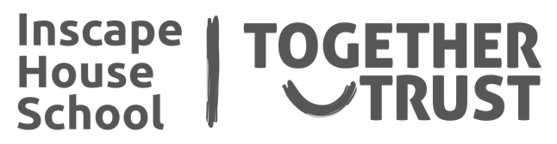

**Creativity - Art**

will be making various garden crafts to decorate the outside communal area and build upon fine motor skills.

We will also look at different nature artist to improve knowledge and provide inspiration to the project.

**Physical Development**

We will explore local countryside and urban environments introducing the idea of walking for enjoyment

**Literacy, Language**

**and Communication**

We will be making craft projects to show our understanding of instructions with more than one point in a variety of situations.

We will continue to read fiction and non-fiction texts based on current events (such as the Queen’s birthday, Ramadan and VE Day) to build on our comprehension skills.

We are extending our knowledge of present and future tenses with a variety of activities and will be making a book about ourselves and where we live (as part of the Portico Art of the Book Award.)

Some of us will be working on Formal and Informal Language.

**Maths**

We will be using a range of concrete materials.

We will be working on Numbers – counting in 10s, making equal groups and experiencing grouping and sharing.

We will start working on Fractions – half and quarter.

Some of us will be extending their knowledge of fractions with equivalent fractions and start comparing, ordering, adding and subtracting fractions with a same denominator.

We will be working on Money Skills – recognising and using coins and notes.

We will be starting to learn the time – or building up our skills using analogue and digital clocks and comparing durations.

**My World - Science**

We will be learning about Seasonal Change.

This will include talking about temperature, different types of weather we could experience in the UK, what happens in nature and clothes we could be wearing at different time of the year.

**These are the exciting things I will be studying this half term…**

**Understanding Me and My Relationships**

We will be looking at the concept of safe strangers knowing who it is safe to approach when you are in trouble in the community.

This will be explored by travel training locally and on public transport.

**My World – Food Technology**

Learning the skills needed to make Pancakes and looking at the processes involved.

**Creativity - Music**

This will be a person-centred approach according to the student’s interests. We will cover singing and ukulele.

**My World - Humanities**

We will be experiencing new places in the Forest School area.