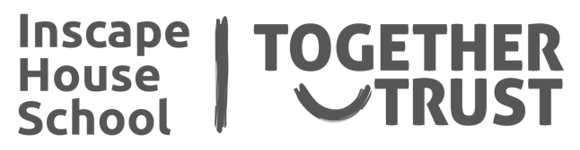

**PSHE**

**I will be learning about:**

**People who help me - emergency services**

**Strangers/ people I know.**

**Understanding the world**

**Food Technology: Food Around the World – tasting and exploring different tastes and textures, basic cooking skills**

**ICT: Input and Output**

**Life Skills: Independence- personal hygiene, dressing skills, money skills, work skills, transitioning**

**Physical Development**

**I will be doing a combination of:**

**Swimming**

**Music and Movement through Jabadao**

**Cycling**

**Walking**

**Drama: Explorers: Role Playing**

**My World – Science**

**We are ready to explore all things Rocks, fossils and soils.**

**We will be looking at a wide range of rocks and putting them into categories.**

**Literacy, Language and Communication**

**My Own Environment- Non-Fictional Text on Inscape.**

**Names and nouns – naming familiar objects and people.**

**Sentence work and basic punctuation.**

**Maths**

**A rolling programme of:**

**Numbers, Sequences, Shapes, Calendar and Time, Days of the week, 1-2-3 (now, next, then), Measures, More/ less, Position and Movement, Stop/ go**

**Expressive Arts**

**Collage and mosaics**

**Music: Composition and performance, listening skills - Inscape iPad ensembles. Compose and perform as a group using virtual instruments.**

**Listening to and express an opinion on music based on musical tastes**

**These are the exciting things I will be studying this half term…**