

**ICT**

This half term students will be studying Computer Graphics. Students will learn about Vector and Bitmap Graphics and examine the difference between the two. Students will learn about how Vector graphics are produced and will create and manipulate objects to form a logo design. Pupils will learn about layers, text, saturation, brightness/contrast and will use a Graphics Package (Photoshop) to create an artwork (poster).

**Art**

This half term we will be looking at 3D sculptures and artist research - Ernst, Dali, Man Ray, Andre Masson, Magritte etc**,** collage**,** printing**,** combining materials**,** photograms**, a**utomatic writing /drawing composition.

**Maths**

This term pupils will continue working with fractions and percentages. All pupils will be provided work at their individual working level to challenge them appropriately. This will be taught using a range of methods including bespoke worksheets and practical techniques to help engage our young learners with the curriculum area.

**RE**

Humanism. I will learn about:

* What are the key principles, beliefs and practices of Humanism?
* How do Humanists mark key events in life?
* What are atheism, agnosticism and secularism and how do they relate to humanist worldview?

**English**

The novel “Windrush Child” by Benjamin Zephaniah. I will be:

* Looking at the social and historical context
* reading and interpreting primary and secondary sources
* writing persuasive letters, adverts
* taking part in debates and discussion
* using structural devices in a text
* describing setting
* making critical comparisons across texts

**Food Technology**

Where does our food come from?

* Food Miles
* Where around the world does our food come from?
* Different food producers around the world.
* Sustainable ingredients

**These are the exciting things I will be studying this half term…**

**Science**

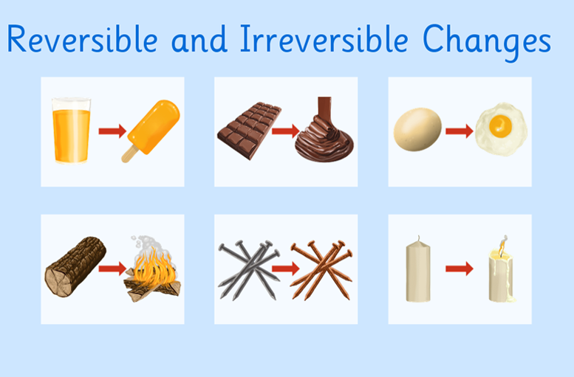

Students will study the difference between chemical and physical changes. They will also learn how the Periodic Table was assembled and why elements are grouped the way they are.

Students will begin to build relationships using their analytical and practical skills.

**PHSE**

Intimate relationships. I will be looking at:

* Relationships and sex education
* Consent
* Contraception
* the risks of STIs
* and attitudes to pornography

**History**

Blending cultures in twentieth century. I will be focussing on:

* The Cold War
* China &Mao
* Windrush
* British & Asian clash of cultures